Backup copy of your passwords, to be provided to United Way
(WAIT TO COMPLETE WITH INSTRUCTOR)

Tax Volunteer Name: __________________________________
Email address used to set up passwords: __________________

TaxSlayer Practice Lab:
User ID: ____________________________
Password: __________________________

Link and Learn Certification Test:
Username: _________________________
Password: __________________________

United Way Volunteer Tax Training (VITA)
Tax Year 2022

LINK AND LEARN NOTES
Contact for Tax Certification Test Questions: 205-458-2088 (Judy Allen),
Contact for Volunteer Coordination: 205-251-5131 ext 5645 (Waneka Johnson)
or email: taxvol@uwca.org (reaches both of us)

Home Page for Link and Learn: https://www.linklearncertification.com _____________________________________________________________________
- Tax Law Review:
- If you are not familiar with tax law: Review this package, including selected pages from Publication 4012
- Complete Publication 4012 available online at https://www.irs.gov/pub/irs-pdf/p4012.pdf
- Complete VITA/TCE Training Guide https://www.irs.gov/pub/irs-pdf/p4491.pdf
- Additional training materials are posted on https://www.linklearncertification.com

- How to use TaxSlayer Software to Prepare Returns that are part of the test:
- Set up an account in the TaxSlayer Practice Lab:
Use Google Chrome or Microsoft Edge, but not Mozilla Firefox.
- https://vita.taxslayerpro.com/IRSTraining . There also links on the LinkLearnCertification page.
- The page will say “Practice Lab” at the top.
Enter Password in all caps – TRAINPROWEB.
- Set up your User Name and Password. Hopefully you can use the same User Name for both the Practice Lab and the Test. If will ask for our SIDN =S66017881.
- Returning volunteers can use the password they used last year, if they still have their package, or reset the password.
- Make note of what you set up:
User ID: ______________
Password ______________ (use one that you remember easily)
- There are video tutorials on preparing returns in TaxSlayer, available for you to watch.
- If you have a copy of the test, start preparing the tax returns from the test here, starting with Basic Scenario 7. For Social Security numbers and other Tax ID#’s the 4th and 5th digits will be zeros. You can make up the last four digits.

Be sure to look up the answers for both test and retest questions while you have the tax return open, and mark in your book.

III. Link and Learn Certification Test (Where you log in to take the actual test) https://www.linklearncertification.com. On left side of page, click “Create an Account”
Try to use the same ID and Password as for TaxSlayer if available.
BE SURE TO LIST YOUR NAME AS IT IS LISTED ON YOUR DRIVERS LICENSE OR OTHER ID

Link and Learn Test User ID _____________
Link and Learn Test Password ____________

This USER ID and Password will be sent to your e-mail. If it is lost, you can register for a new one, but you will not be able to access your work under the original user ID.

You only get two tries to pass the test, with a score of 80 or higher. Prepare the questions in the Test sections of your book, to be prepared to enter your answers to the same questions on the online test.

To check the accuracy of your answers before taking the test, you can use this checker tool provided by one of our partners: Basic: https://tinyurl.com/26vqfg8w and Advanced https://tinyurl.com/2ayt28qq . It will tell you if your answers are correct and provide hints if you missed it. If you have follow up questions, email us at taxvol@uwca.org for further help.

Have your book ready as you take the test, and read the questions carefully. Take your time. You can log out and in again, and can go back to edit answers of previous questions until you press submit.

**Before pressing submit, print the summary page with the list of your answers, so that you can refer back to this to see how you answered the questions you missed. (You will not be able to retrieve this information again once the test is scored.)

If you do not pass, email us at taxvol@uwca.org to review your responses to clear up missed questions before trying a second time!

WHEN YOU PASS EACH TEST – EMAIL US YOUR VOLUNTEER AGREEMENT to taxvol@uwca.org !

See the illustration for instructions to submit your agreement. Be sure to check the box to electronically sign the agreement.

When you complete the Certification Test, check the box in Link and Learn to sign the Volunteer Agreement, then print and save as a .pdf

Send Volunteer Agreement to United Way of Central Alabama
- By E-mail to taxvol@uwca.org. (Preferred-Mailbox specifically for receiving certifications)
- Please include your daytime telephone number with the e-mail.

Judy C. Allen, PMP
Director – Volunteer Income Tax Assistance, United Way of Central Alabama
3600 8th Ave. South, Birmingham, AL 35222
P. O. Box 320189, Birmingham, AL 35232-0189
Phone: (205) 458-2088

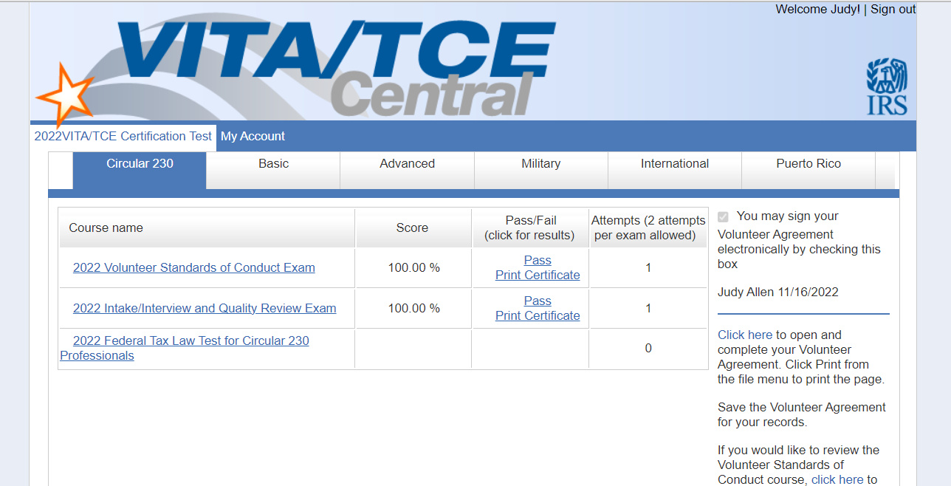

DO Send us this, to TaxVol@uwca.org DON’T SEND US THIS…..it’s to frame, brag about to your friends, or post on Facebook!

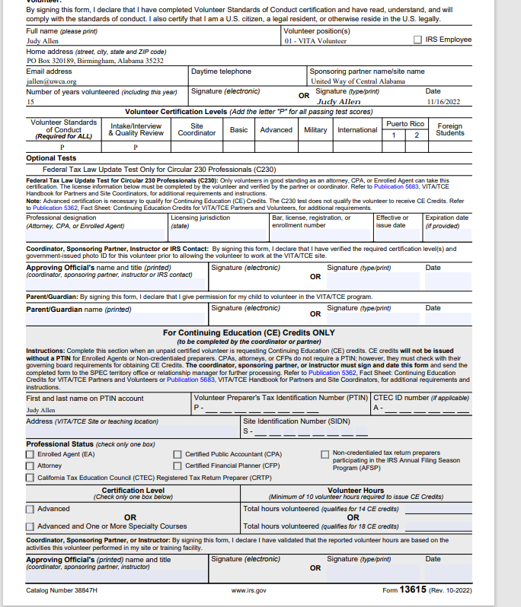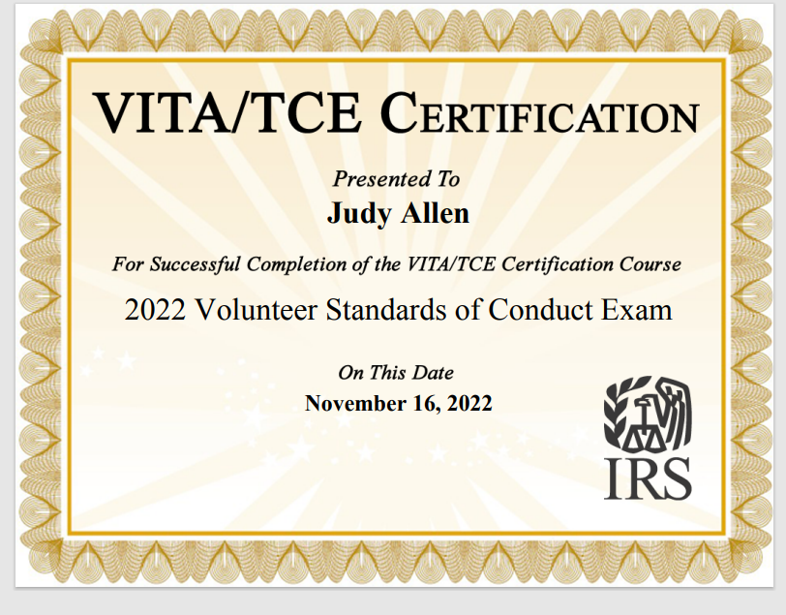

Study Supplement – VITA Volunteer Standards of Conduct

Review Volunteer Standards of Conduct Course available at this link, http://www.irs.gov/pub/irs-pdf/p4961.pdf or after logging in to the
in the lower right corner on www.linklearncertification.com

Highlights of Volunteer Standards of Conduct Agreement:

All volunteers must pass the test with a score of 80% or higher prior to volunteering, and sign Form 13615, Volunteer Standards of Conduct Agreement: Greeters, Tax Preparers, Quality Reviewers, Site Coordinators

Violations of Volunteer Standards of Conduct can result in 1) Removal/being barred from VITA/TCE program, 2) Criminal Investigation, 3) Elimination of Grant Funds, and 4) Deactivation of EFIN (electronic filing number)

Do not solicit accept tips, payment or donations – politely decline. As a VITA site, we cannot accept payment for our services. (If customer wishes to donate to United Way, they can visit www.uwca.org after they leave the tax site.)

For Direct Deposit, the customer must have their name on the account receiving the deposit. Do not offer to direct deposit refund to your account, and do not advise customer to direct deposit to another family members account if the customer is not a signor on the account.

Do not use taxpayer information to solicit business, dates, or any personal gain for yourself or any family member.

Volunteers knowingly preparing a false return , for example by excluding income from tax return, are in violation of standards of conduct. Volunteers who make an honest mistake are not in ethical violation, but will be provided feedback on the mistake and how to avoid in the future.

Volunteers whose activity inside or outside of tax site would have a negative impact on taxpayer trust in the program will be asked to leave, and the details should be reported to IRS-SPEC by sending an email to WI.VolTax@IRS.gov.

All volunteers are required to use the Intake/Interview Process including fully completing each question onform 13614-C for each taxpayer, to discuss the taxpayer’s response and ask follow up questions, and to match the return to be prepared to the certification level of the volunteer.

During Quality Review, taxpayer should 1) actively participate and 2) be reminded that they are responsible for the information on their tax return.

Each site is required to have a process to ensure that the taxpayer is assigned to a preparer with the appropriate certification. At our site this takes place during the Intake/Interview: in reviewing the intake sheet, if an item is marked that is Advanced, match the taxpayer with a person with that certification. Use additional detailed information from discussion with the taxpayer and review of documents to determine whether the return will require Basic, Advanced. Both Preparers and Quality Reviewers for a return requiring Advanced Certification must have Advanced Certification.

To prevent identity theft, photo ID is required for taxpayer and spouse, along with verification of Social Security number for all family members on return, using Social Security card, or SSA1099.

Study Supplement – VITA Intake/Interview and Quality Review Certification

Volunteer programs must use 13614-C Intake/Interview Sheet along with an effective interview for every return prepared at the site.

Before starting the return, the volunteer preparer should:
-Make sure all questions on 13614-C Intake/Interview Sheet are answered, and any items marked "Unsure" are clarified to a "Yes" or "No"
- Complete all Certified Volunteer Preparer shaded questions with the taxpayer (such as for dependents, and for medical coverage)
-Check to make sure the return is within the scope of the VITA program. Identify the certification level required for the return, and make sure that the return is within the certification level.
-As soon as possible, verify that taxpayers have 1)Photo ID, 2)Social Security Cards for each family member, 3)All income statements including W-2, 1099-R, etc. prior to beginning return.

When reviewing form 13614-C, if taxpayer marks "yes" for a type of income, and provides a document for that income, ask if they have any other income of that type, and if so, gather appropriate documents.

Every return must have Quality Review by a separate person than the volunteer who prepared the return. Quality Review is an effective way to ensure the accuracy of the completed tax return.

Receipts for donations are recommended, but if a cash donation does not seem questionable you are not required to see proof. Advise customer to retain any receipts that they have with their tax records.

Proof of Insurance is not required unless the information seems unusual or needs clarification. However, if the taxpayer has Affordable Care Marketplace coverage, they must provide Form 1095-A to complete the return.

To prevent identity theft, each taxpayer should provide photo identification; exceptions must be approved by Site Coordinator. (NOTE Current Drivers License or Non-Driver ID required to efile an AL return.)

The taxpayer should not sign the return until the Quality Review is complete and the taxpayer has been advised of their responsibility for the return.

VITA programs must have a process to ensure that volunteers have the certifications that correspond with the type of returns they prepare.

The Quality Reviewer must have at least the same certification level as was required to prepare the return. Quality Review is an effective tool for preparing an accurate tax return. Self-review is never an acceptable substitute.

As part of intake each site is required to: Have a process to ensure a return is within the scope of the VITA/TCE program, Identify the certification level required to prepare a return, and have a process to ensure volunteers have the certification needed for the returns they prepare.

Include Basic and Advanced Study Guides here.

