HAVE YOU ATTENDED TRAINING OR VOLUNTEERED WITH US BEFORE?

Please retrieve your Username and Password BEFORE coming to class, if you do not remember it:

- Set up an account in the TaxSlayer Practice Lab:
Use Google Chrome or Microsoft Edge, but not Mozilla Firefox.
- Go to www.LinkLearnCertification.com and select “Practice Lab”
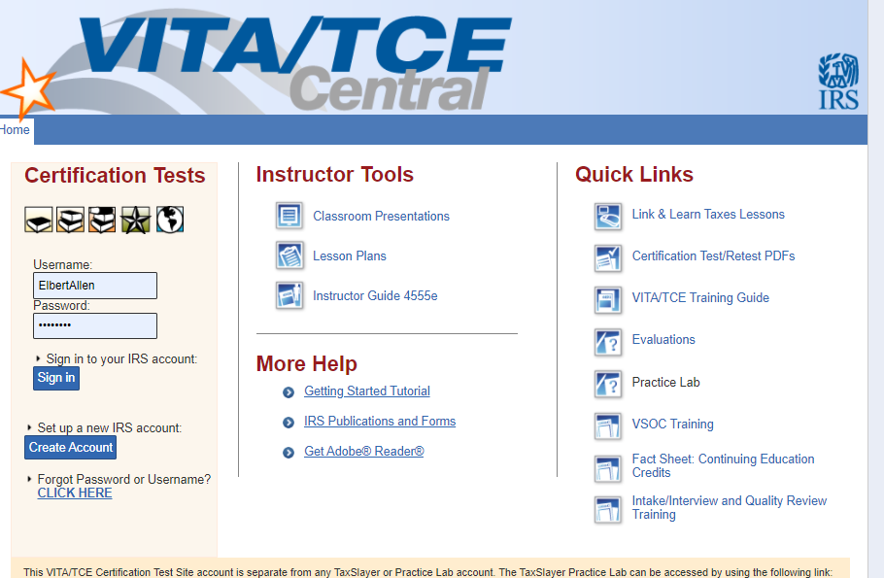

- The page will say “Practice Lab” at the top.
Enter Password in all caps – TRAINPROWEB.

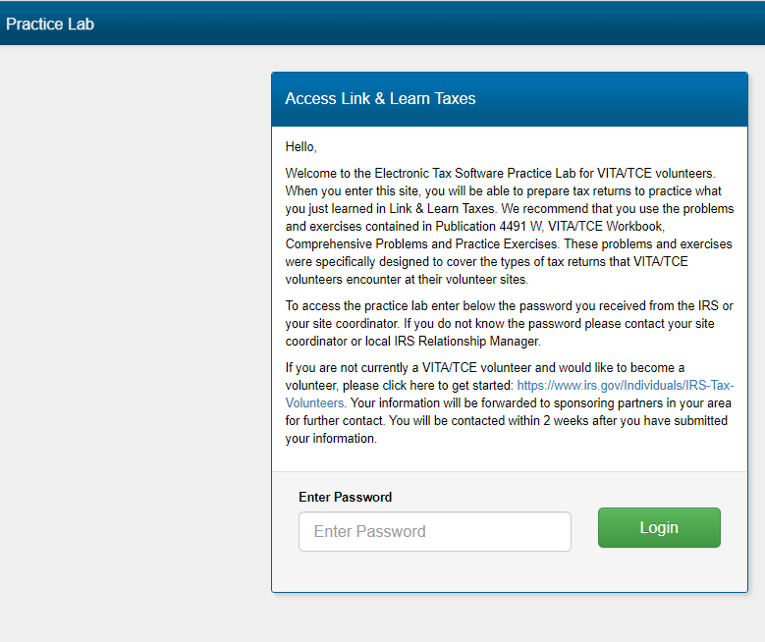

- Try creating a username. If you get a message that this email is in use, then
Click Forgot Username
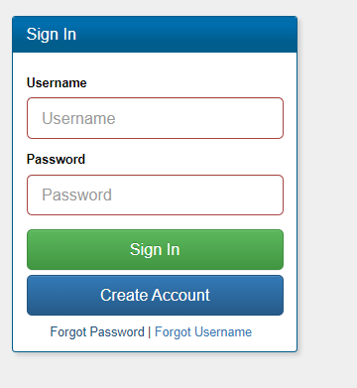

Enter the email address that you used when you attended training before, and the message will be sent to that address from vita.taxslayerpro.com support@e.vita.taxslayerpro.com. It may take 30 minutes or more.
MAKE NOTE OF YOUR USERNAME HERE: ______________________

- Click Forgot Password,
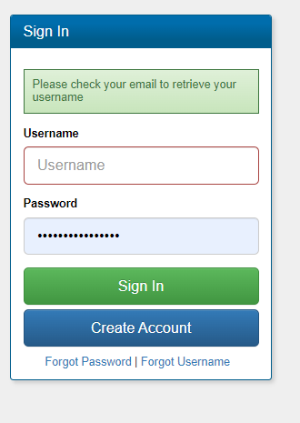

- Enter Username that you just retrieved and click submit.

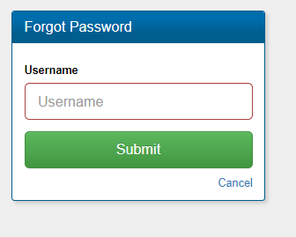

- Follow instructions to reset password. Password requirements shown below:
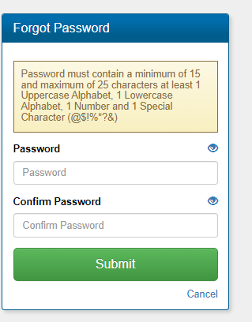
Note the password that you chose: _________________________________.

- 1. Link and Learn Certification Test (Where you log in to take the actual test) https://www.linklearncertification.com. On left side of page, click
“Forgot Password or Username”. Try to use the same ID and Password as you set up above for TaxSlayer to simplify login.
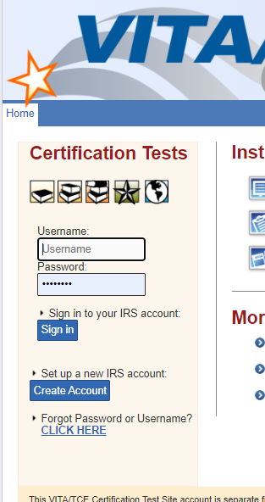
2. After you click, you should see this screen:

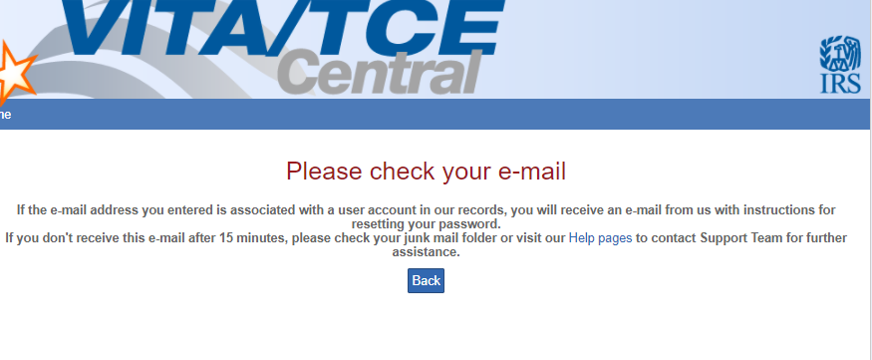
3. You should receive an email like this, from Linklearnsupport@redcedarconsultancy.com

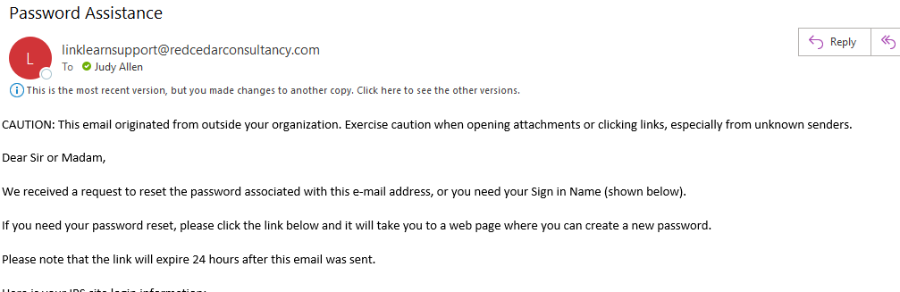

4. Make note of the User ID and Password received:

Link and Learn Test User ID _____________
Link and Learn Test Password ____________

Return to Linklearncertification.com page to log in.

5. Click on tab for My account, and make any updates needed:
Make sure your name matches the way it is listed on your driver’s license
Update your address and any other information that has changed.
